Commander (ENTJ-A)

WEEK 2
Course: MAN 4771
Instructor: Torres Rodriguez
Date: 09/07/25
Commander (ENTJ-A)
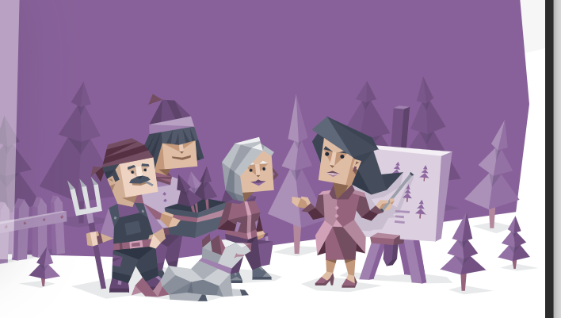
Part 1: Self-Reflection
My personality type is a Commander (ENTJ-A), which is represented by a leader who stands still and firm in decision-making skills. The description that I relate to is one that involves decisiveness and strategic thinking. Another description that I relate to is that of being confident and self-driven because I see myself taking charge in situations where people around me look lost and in need of direction. A good example can be seen during work projects; I mostly become the organizer, setting timelines and distributing tasks among my team members. The other thing I relate to is the description of being goal-oriented and rational; that means in times where there are challenges, I analyze facts and then work to get practical solutions.
The personality trait that I connect well with is being bold, whereby I can pass on my opinions with clarity and inspire other people to follow them. In addition, another trait I relate with is being enthusiastic and assertive, and from it I am driven in my quest to pursue goals even if they may look unattainable, and it cannot go wrong. I still persevere. Nonetheless, there is something that came as a surprise to me: I found that my determination can lead me to become more dominant over others without noticing, and this can make me be more considerate of other people’s points of view. There are times when I find myself becoming so impatient when results appear to come slowly, even when I am working in a group.
Part 2: Growth & Development
For growth and development, I need to ensure that I uphold assertiveness and have empathy. I feel that, since I am naturally a leader, to have good connections with people around me, I need to be listening more actively to their input whenever they are making any kind of contributions in discussions (Anghelescu & Sîrbu, 2023). In addition, I have also found out that I need to develop adaptability to help me gain control of any situation where the outlined plans fail to go the right way as anticipated; I will not be frustrated, and I will become more resilient. In a professional setting, it may be hard work, especially if there are sensitive people around. The criticism is that the case can be perceived as negative since I communicate so straightforwardly, and people may have a different perception of what I am trying to say (Skidmore, 2020). What I can also do is to make sure that I learn to control my delivery and show some concern or emotions to foster a great relationship with others. Also, I can think strategically. As I am more aligned with my team members on the goals we share, I can also respect their different perspectives.
Part 3: Career Alignment
The recommended careers for this personality are lawyer, teacher, entrepreneur, judge, scientist, and politician. This personality involves decisiveness and being orderly, so these careers connect with me. My current goals are to be a logical and efficient leader and a problem-solver; thus, I find these careers to match my goals. The personality makes me see leadership as providing direction and motivation to others with a clear vision and ensuring that the group I am working with achieves success. In teamwork, I help others observe deadlines and work on the tasks that they are assigned. I also ensure everyone contributes ideas to the team to achieve the goal effectively.
In conclusion, the weaknesses in my personality type are due to the dominance aspect. To ensure that I do not conflict with other personalities, I can foster well-balanced relationships by learning to control my delivery and being more adaptable.
References
Anghelescu, A., & Sîrbu, M. (2023). Exercises to Develop Active Listening and Meaningful Conversations. In Teaching Science Students to Communicate: A Practical Guide (pp. 443-450). Cham: Springer International Publishing.
Skidmore, M. R. (2020). The Connect Project: BRANCHESS: Building Relationships and Nurturing Connectedness Harnessing Every Student's Success (Doctoral dissertation, Morehead State University).

